

**Mathematics Specialist**

**Unit 3**

**TEST 2**

**Student name:** _______________________  **Teacher name:** _______________________

**Time allowed for this task:** 50 minutes, in class, under test conditions

Calculator-Free

**Materials required:**

Standard items: Pens (blue/black preferred), pencils (including coloured), sharpener, correction fluid/tape, eraser, ruler, highlighters, SCSA Formula Sheet.

Special items: Drawing instruments, templates

**Marks available:** 44 marks

**Task weighting: 8%**

**Question 1 (3 marks)**

If 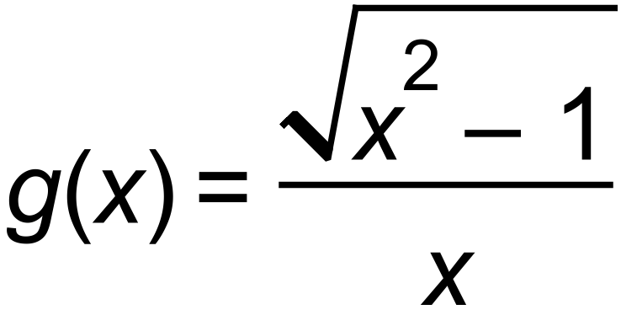 ,find all solutions to:

(a) 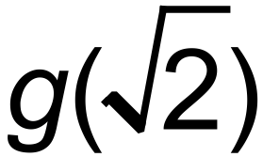

(b) 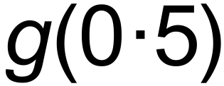

**Question 2 (4 marks)**

State the domain and range of the following.

(a) 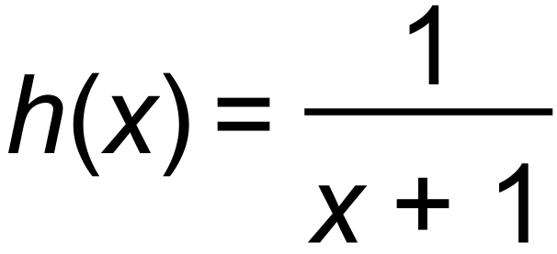

(b) 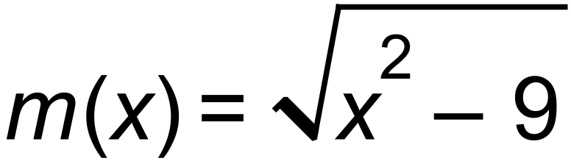

**Question 3 (8 marks)**

The functions *f* and *g* are given by



(a 

(3 marks)

(b) On the axes below, sketch the composite function 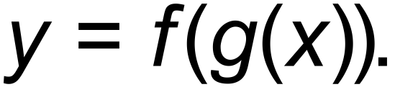 (2 marks)

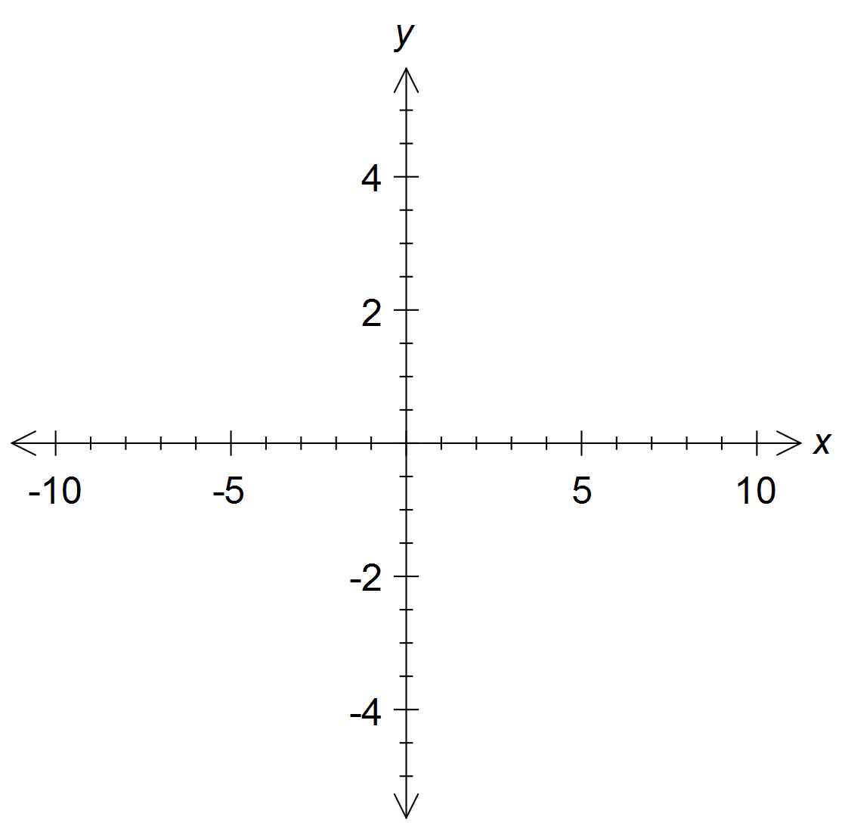

(c) How should the domain of 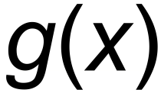 be changed so that 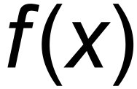 and  are

inverse functions of each other? (3 marks)

**Question 4**  **(10 marks)**

The function 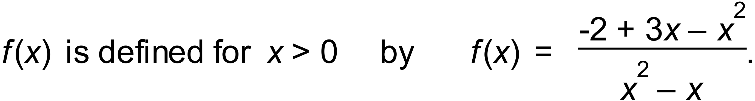

(a)Sketch the graph of  (4 marks)

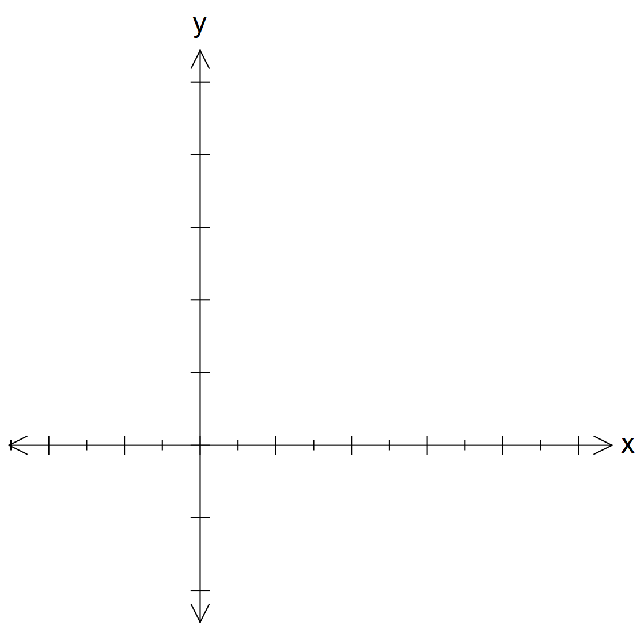

(b) What is the range of 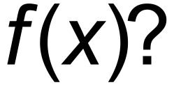 (2 marks)

(c) Show that 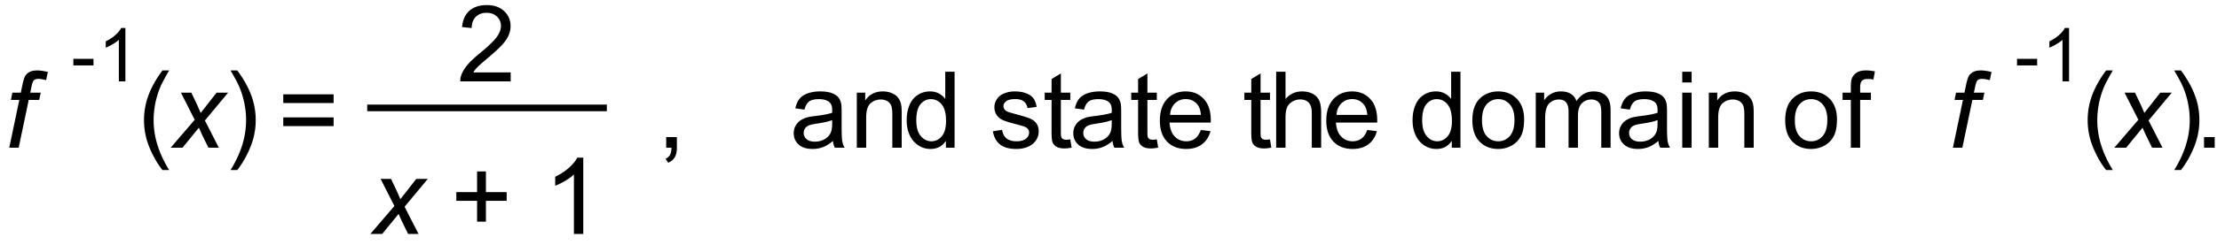

(2 marks)

(d) Sketch the graph of 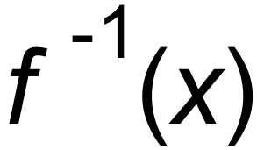 on the ***same axes used for part (a)***.

Label your sketch clearly. (2marks)

**Question 5 (5 marks)**



**Question 6 (6 marks)**

Sketch the rational function 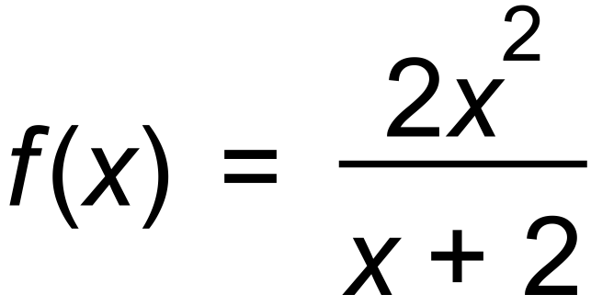

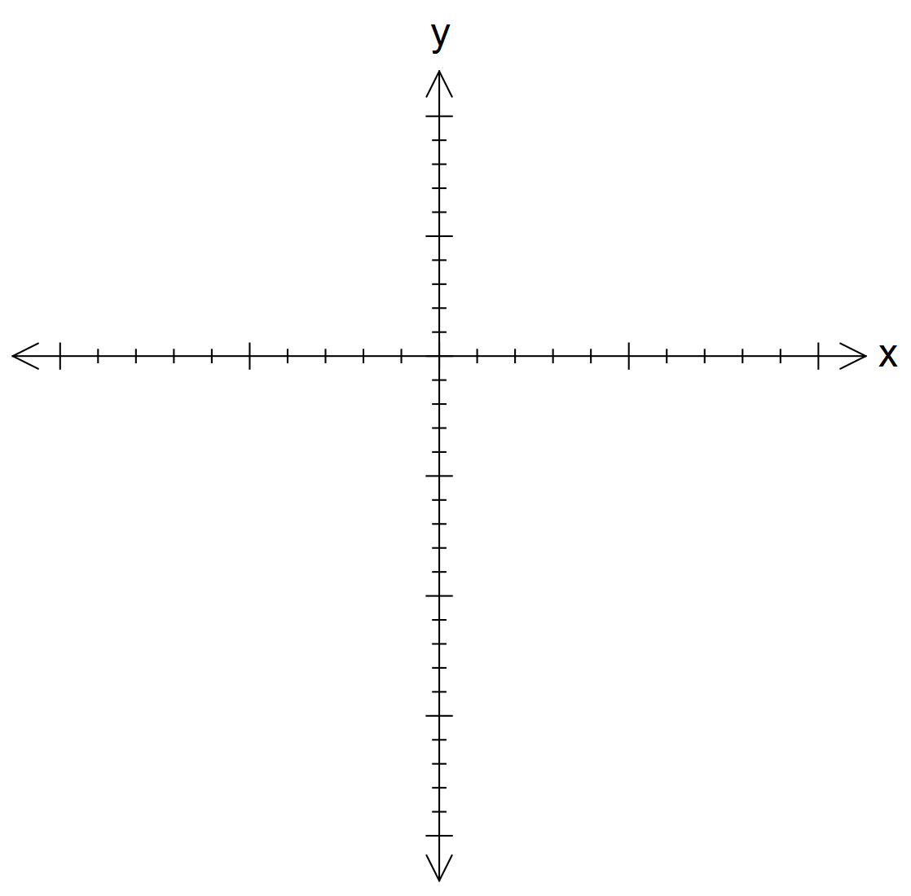

**Question 7 (8 marks)**



# 